Single Seed Descent

Reading: Fehr – Chapter 23

Single Seed Descent (SSD) describes a protocol utilized during the inbreeding of populations of self-and cross-pollinated species in the development of homozygous lines. It is commonly utilized in cultivar development of species amenable to the growth of more than one generation per year (e.g. soybeans, peanut, spring-sown small grains). Land and labor costs in off-season nurseries are high, so the relatively low space and labor requirements for the implementation of SSD make it an attractive procedure for rapid inbreeding.

The method traces to Goulden (1941, Proc 7th Int. Genetics Congress) although he did not use the term ‘Single Seed Descent’. He noted that a wheat breeding program could be divided into two stages: a) the development of pure lines from segregating populations and, b) selection among the resulting pure lines. He noted that a protocol such as the pedigree method limited generation advance and selection to only one season per year because plants had to be grown in an environment in which genetic differences are expressed. In addition, the pedigree method is based on the premise that progress in obtaining lines with the required characteristics can be made at the same time as the lines are being advanced to homozygosity. While this is true for high heritability traits, most cultivar development programs are working with numerous low heritability traits for which little progress can be made prior to replicated evaluations. Goulden’s alternative was to separate the inbreeding and selecting generations in order to speed the process along. He proposed a model for spring-sown cereals. The number of progeny grown from a plant in each generation should be one or two only, and two generations should be grown in the greenhouse and one in the field per year. In this manner, he could attain the F₆ generation in two years, as opposed to five years with the pedigree method. After the desired level of homozygosity was achieved, the lines would be tested for desired characteristics.

Implementation:

A very general outline is presented below; most programs have their own subtle, and not-so-subtle, alterations. The UK Wheat Breeding program does not routinely conduct SSD because we cannot utilize off-season nurseries due to the vernalization requirements of fall-sown small grains, i.e. the plants must go through an extended cold period before they enter a reproductive growth phase. However, we will probably use it more often as we are able to genotype parents. If I was breeding spring-sown small grains, which do not have a vernalization requirement, I would likely utilize SSD extensively because of the rapidity with which one obtains homozygous lines. U.S. and Canadian spring-sown small grains breeders utilize winter nurseries in Arizona, New Zealand and Argentina. The NC State peanut and soybean programs use SSD and off-season nurseries in Puerto Rico.

SSD would typically be implemented in the F₂ generation and segue into a generation of head-to-row visual selection followed by extensive replicated evaluations of advanced generation lines. But there are certainly no firm rules on how it should be conducted.
One typically conducts SSD through the F₅ or later generations, but it may be conducted for a lesser number of generations. The goal of SSD, in its purest form, is to produce a set of inbred lines that represent the entire range of variation in the original F₂ population. Maintenance of the complete range of genetic variation is very important when developing a set of Recombinant Inbred Lines (RILs) for an academic study (discussed below), but is not the most efficient method of generation advance in a cultivar development program. Disease, insect, abiotic and other natural selection pressures would be discouraged in a RIL development situation, but could be promoted in a cultivar development program. Brim (1966. Crop Sci. 16:220) outlines the use of SSD in a cultivar development situation, with selection during inbreeding. He refers to the procedure as the ‘Modified Pedigree Method’. This is a bit of a misnomer because the method outlined is much closer to SSD than it is to the traditional Pedigree method.

Season 1. F₂ plants are grown in a plot that accommodates a minimum of several hundred plants. Planting rate and spacing permit identification of individual plants at harvest. Depending on the situation, one may impose visual selection on individual plants for high heritability traits. Hand harvesting is required and a single F₃ seed from each plant is placed in an envelope for planting the following generation (thus one planting envelope per population). For practicality, one head or one pod may be harvested from each plant in the field, but a single seed from each head or pod is put into the planting envelope at a later date. Typically a second seed would be placed in a reserve envelope and kept in cold storage in case of a catastrophic loss in the field.

GENERALIZED SINGLE SEED DESCENT PROTOCOL

Season |  | Procedure
1 | Plant 500 F₂ plants.  Harvest 1 seed per plant.
2 | Plant 500 F₃ plants.  Harvest 1 seed per plant.
3 | Plant 500 F₄ plants.  Harvest 1 seed per plant.
4 | Plant 500 F₅ plants.  Harvest individual plants.  Keep F_{5:6} seed separate.
5 | Grow one rep of F_{5:6} lines  Harvest best lines in bulk.
6 | Extensive multi-environment  testing begins (F_{5:7}).

Jansen and Jansen (1990. Euphytica 51:131-140) provided tables that list the minimum and maximum numbers of plants that must be selfed each generation to obtain desired inbred genotypes in the F₆ generation. For example, to recover an AABB homozygote with a probability of 0.95 from a cross between AAbb X aaBB parents (loci unlinked) then one needs to self 12 to 22 individuals each generation (below). Of course most breedeng programs would self and advance several fold that number because they are improving more than one trait.

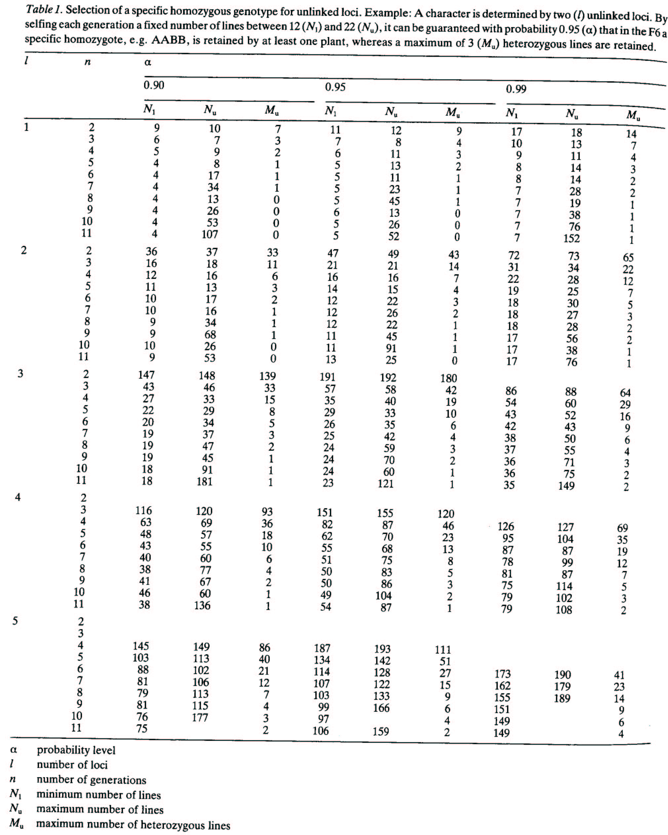
With repulsion phase linkage in the F₁ generation (Ab/aB) and a recombination rate between the loci of 0.1, then it will be necessary to self 42 to 63 individuals per generation to obtain the desired genotype (AABB) with a probability of 0.95 in the F₆.
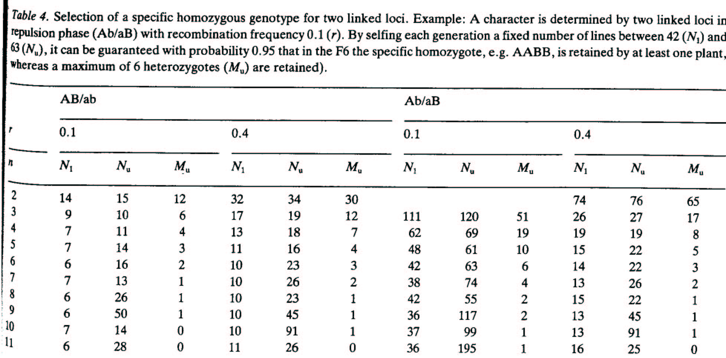

There will be a loss of lines of descent during the inbreeding process even without conscious selection. A host of different reasons can be involved, for example some seeds will fail to germinate, a low level of mutation will result in severely deformed plants that are sterile, deer will graze the nursery etc., etc. If one desires to obtain, say, 200 plants in the F₆ generation then one needs to calculate the number of seeds that must be planted in the F₂ given an expected 20% attrition rate per generation. It is better to end up with a few extra plants than with too few.

Seasons 2 through 4: The procedure is repeated over seasons. Every second season will likely utilize an off-season nursery. This reduces by one-half the time to reach the advanced line replicated testing phase. Nevertheless, some breeders advance materials through two ‘off-season’ nurseries between each ‘home site’ generation. The ability to do so depends on climatic variables and the generation time for the crop involved. Travel to exotic climes is not always required because generation advance can be achieved in controlled environment greenhouses and growth chambers. The number of populations advanced in such facilities is greatly limited and only utilized on specific targeted populations. In the example above, individual plants are harvested in season 4 and F_{5:6} seed from each plant is placed in its own envelope.

Season 5 and later: The F₅- derived lines are evaluated for the characters of interest in the same manner (over replications, locations, and years) as lines derived from other methods of inbreeding. However, unlike lines emerging from the Pedigree, Bulk or Mass selection procedures, SSD insures that every line entering advanced generation testing traces to a different F₂ plant. If the F₂ sample was sufficiently large, then the materials entering advanced generation testing should be a broad representation of the variability in the cross.

In comparison to advanced generation lines derived from standard Mass / Pedigree selection protocol, the lines derived by SSD certainly had more genetic variation for many traits. However, it often seems that most of this variation was at the low end of the trait distributions. If I used SSD routinely in a cultivar development situation, then my goal would be to derive 50 to 100% more advanced generation lines per population for entry into the first visual ‘head-row’ generation than I enter in the first visual ‘head-row’ generation following Mass / Pedigree selection. A significant number of inferior types are carried along with SSD, especially when selection for high heritability traits is omitted.

Casali and Tigchelaar (1975. J. Amer. Soc. Hort. Sci. 100:364-367) observed a similar trend in a computer simulation study. They concluded that strict SSD required the breeder to maintain larger numbers of advanced generation lines to compensate for the breeding progress achieved through pedigree or mass selection. For traits with high heritability (>50%), strict SSD did not compete well with Pedigree or Mass selection in producing superior homozygous lines. With low heritability traits however, maintaining a larger number of lines with a SSD protocol more than compensated for the slow rate of genetic progress achieved through Pedigree or Mass selection. The authors suggested that breeders should consider Pedigree selection in early generations (F₂, F₃) to make progress on high heritability traits, followed by several generations of SSD to rapidly advance selected materials through homozygosity.

Is a single seed from each F₂ plant appropriate? We have seen previously that variation among F_{2:3} lines is σ²_{Α} + 0.25 σ²_{D} and variation within F_{2:3} lines is 0.5 σ²_{Α} + 0.5 σ²_{D}, so one can envision the store of genetic variation that is found among the different seeds on an F₂ plant. Taking a single seed from each F₂ plant is quite a gamble if it is a superior plant, given the variation from seed to seed within that superior plant. To paraphrase Dirty Harry ‘Do you feel lucky enough to be advancing the best seed?’ Once a superior cultivar has been obtained through SSD it is too late to test the relative merits of the other seeds from that ancestral F₂ plant that were abandoned. If you feel that emphasis should be given to selection within F_{2:3} lines you may feel uneasy about the SSD procedure because it emphasizes between line variance to the exclusion of within line variance. The genetic channeling that results from taking a single seed per plant when breeding for a quantitative trait may not give a sufficiently large inbred population to include the best genotype (Sneep, 1977. Euphytica 26:27-30).

Boerma, H. A., and R. L. Cooper. 1975. Comparison of three selection procedures for yield in soybeans. Crop Sci. 15:225-229.

Four soybean populations were subjected to Early Generation Testing (EGT), Pedigree Selection (PS) and Single Seed Descent (SSD) from the F₂ through the F₇ generations. The three procedures started with the same F₂ plants and between 10 and 30 lines emerged in each of the four populations for comparisons of the three selection procedures in the F₈ generation.

The EGT protocol involved yield evaluations of F₂-derived lines in F₃, F₄, and F₅ generations which is probably more extensive than one usually considers for EGT. Pedigree selection involved visual selection in the F₃, F₄, and F₅ generations which was standard pedigree procedure. SSD populations were advanced through F₂, F₃, F₄, and F₅ generations.

The means of all selected lines, the five highest yielding lines and the single highest yielding line in each population were not consistently associated with any one inbreeding procedure (below). The lines emerging from the EGT procedure tended to be later maturing than lines from the other procedures and this was attributed to an artifact of
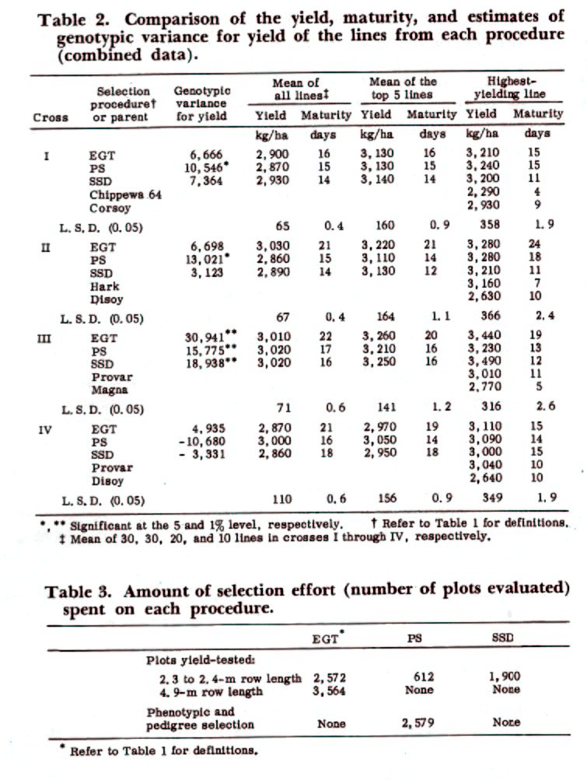
yield testing unbordered plots in early generations. The PS method seemed to retain the highest genetic variance for grain yield, but there was no consistent relationship between variance and frequency of high yielding lines.

Observations of the number of plots grown in the three procedures indicated that EGT required considerably more yield testing than the other two procedures, and the PS procedure required considerable effort in phenotypic selection. The SSD procedure was most efficient in terms of plots grown, permited a rapid generation advance (although off-season nurseries not utilized in this example), and it did not expend resources on expensive yield evaluations until later generations.
Ntare, B. R., M. E. Aken’ova, R. J. Redden, and B. B. Singh. 1984. Euphytica 33: 539-547.

These authors compared the yield potential of F_{4:6} cowpea lines developed using SSD and Early Generation Testing (EGT). One hundred F₂ plants were harvested to provide seed of 100 F_{2:3} lines for EGT and one seed was taken from each plant and bulked to provide for the SSD line of descent. Two plants were harvested individually from each of the 10 highest and 10 lowest yielding EGT lines to provide 40 F_{4:6} lines. One hundred F_{4:5} SSD lines underwent visual evaluation in the field and 40 superior lines were harvested for comparison with the 40 EGT lines.
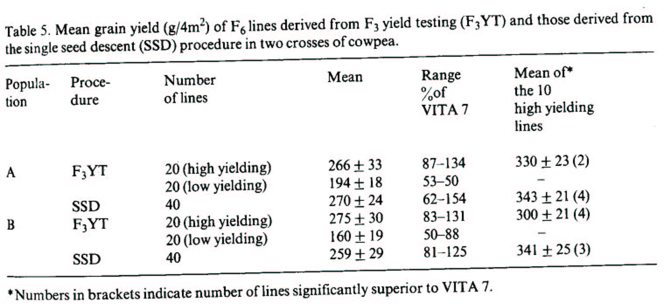

Both methods produced similar numbers of high yielding F_{4:6} lines. The SSD method had fewer low yielding lines, but this was likely an artifact of the EGT protocol which deliberately kept low yielding lines in the program. The generation of visual selection in the SSD program likely eliminated the lowest yielding lines. Both methods resulted in similar numbers of high transgressive segregates. The results indicated that 1) EGT was successful in identifying lines that would have superior yield in later generations, and 2) SSD was as good as EGT in producing high yielding lines in later generations. The choice of method to use depended on resources available.

SSD is a widely utilized protocol for the development of Recombinant Inbred Lines (RILs) for academic studies. Such populations (often referred to as ‘mapping populations’) are valuable because once homozygosity is achieved the inbred lines can be utilized indefinitely without further within-line segregation. In addition, if the parents were themselves inbred lines then only two alleles segregate at each locus. Some important mapping populations have been submitted to the National Germplasm Collection and seed of the RILs can be requested for subsequent research studies by different groups. Thus, additional phenotypic data can be accumulated on the population and new marker data can be added to the existing map.

Single Hill procedure of SSD. If maintenance of the broadest range of genetic variation is very important, a modification known as the Single Hill procedure can be utilized. This method helps insure that each F₂ plant will have progeny represented in advanced generations of inbreeding. Instead of taking a single seed from each plant and placing it in a single envelope with seeds from all other plants, several seeds from each plant (a pod, a head) are threshed into their own envelope. These seeds are planted as spaced hills the following season, and at harvest a single pod or head is harvested for propagation the next year. Because a single pod or head is harvested, sampling is on a single plant basis which is equivalent to SSD. The Single Hill proceedure is more labor intensive and probably not efficient for hundreds of cultivar development populations. It would be appropriate for development of specific recombinant inbred populations.

Using ‘SSD’ or ‘Recombinant Inbred Technology’? Unfortunately the activities of cultivar developers are viewed as old fashioned and an embarrassment to the ‘real’ scientific community by certain university administrators. (NC State CALS administration being a notable exception to this viewpoint). It is interesting that when administrators try to impress the public with an example of the university meeting the public need, they will frequently highlight plant breeding accomplishments, while in the next breath admonish breeders for being old fashioned and unable to bring in large research grants to the university. One way to ridicule this viewpoint, without the offending administrator knowing they are being ridiculed, is to refer to your breeding methodology as the ‘Recombinant Inbred Technology’ method rather than SSD. Buzz words and fluff are important to this breed of administrator and they will be suitably impressed!

The only methodology that can develop homozygous lines faster than SSD is the Doubled Haploid (DH) method. There is one drawback to using DH rather than SSD in the development of RILs. F₁ plants are typically the starting point in the development of DH plants, thus a single meiotic event is the basis of the resulting RILs, i.e. haploid gametes produced by F₁ plants are doubled to produce the doubled haploid population. In contrast, RILs developed through SSD are the product of numerous recombination events, and typically have twice the amount of recombination between closely linked markers. This permits more accurate estimates of map distances because there is more recombination between linked loci (Chart from Burr and Burr. 1991. TIG 7:55-60).
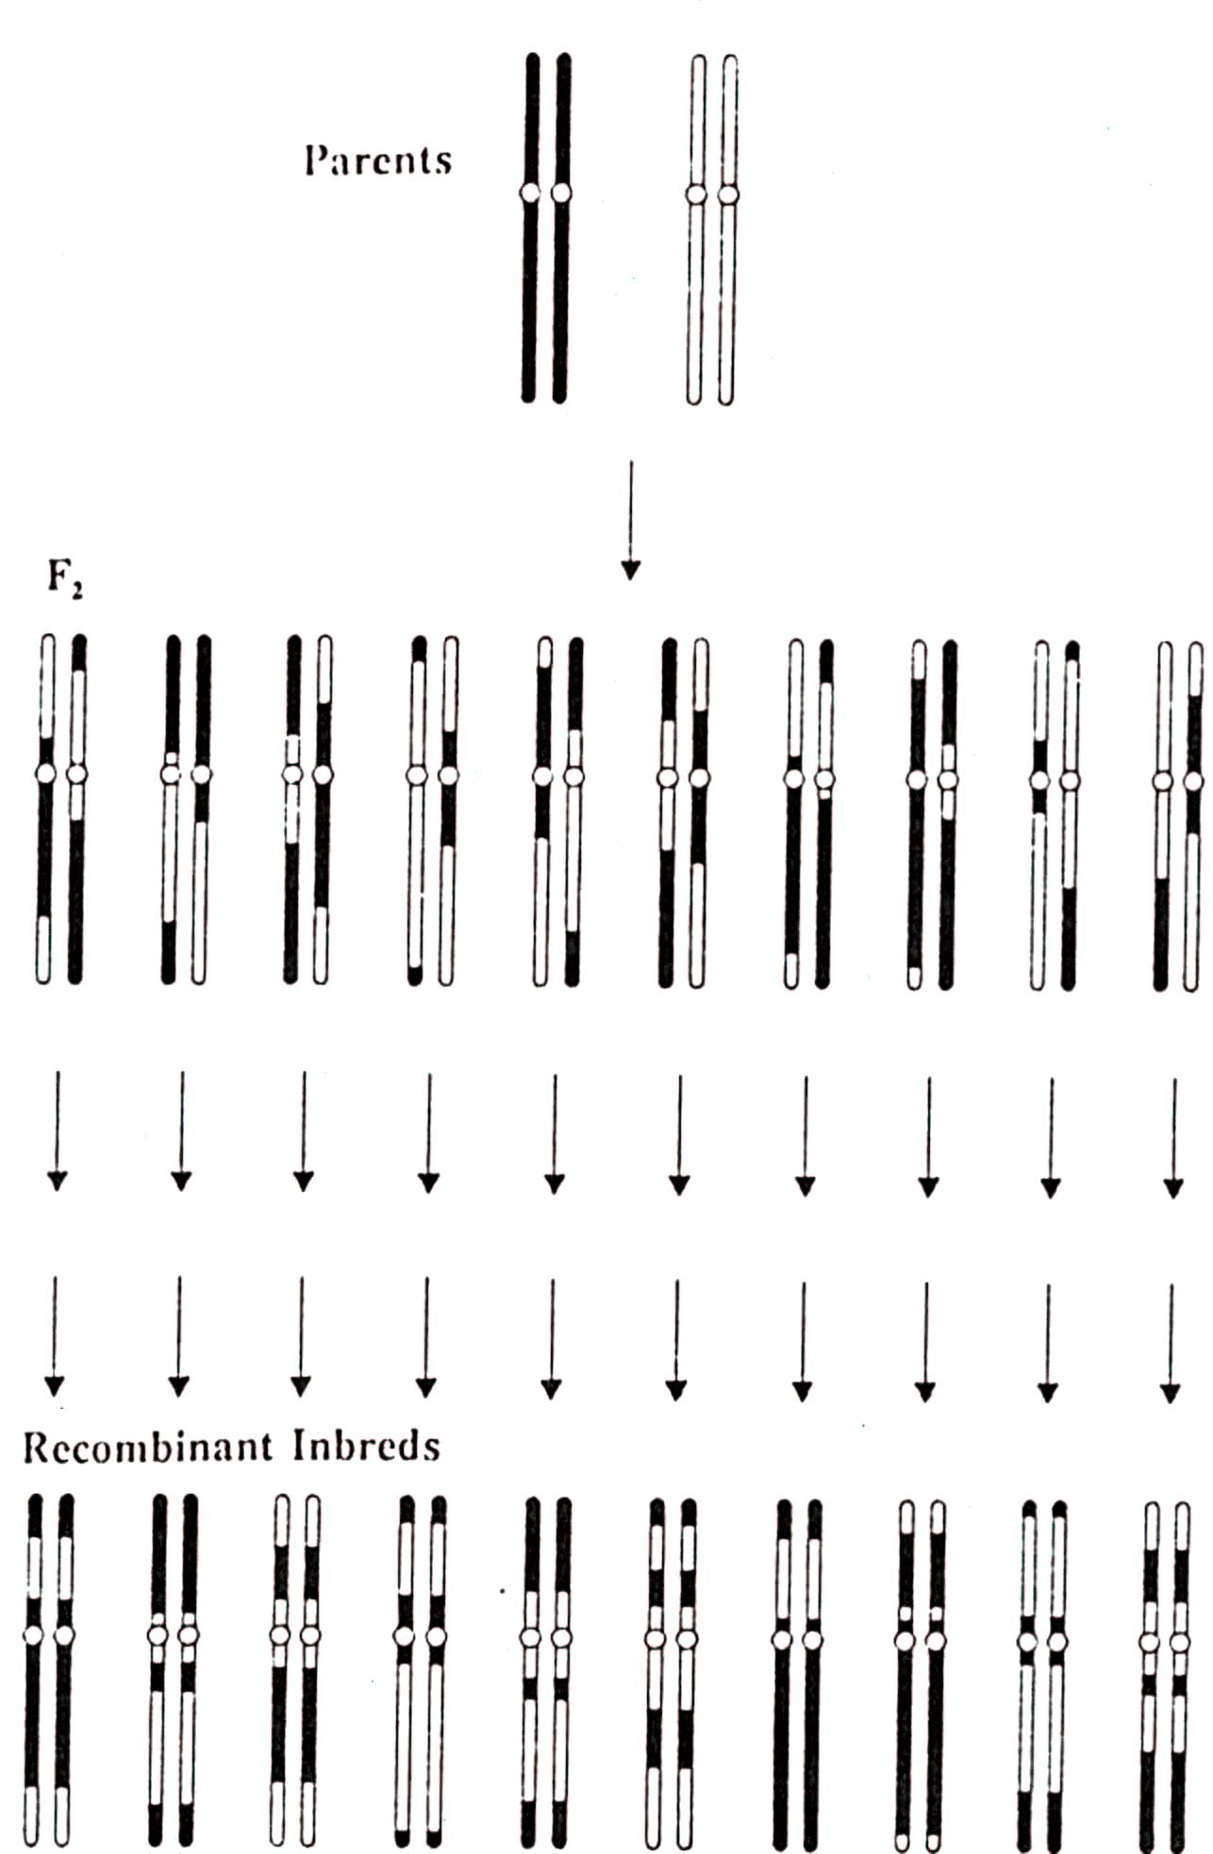

Multiple Seed Procedure of SSD. Harvesting single pods from plants of legume species and bulk threshing the pods is a labor saving procedure utilized in some cultivar development programs. The procedure reduces genetic variation in the population because each of the original F₂ plants is not represented in advanced generations due to sampling variation. Macchiavelli and Beaver (2001. Crop Sci. 41:1513-1516) examined the specific changes by varying the number of seeds per pod (2 to 6), and number of plants sampled (100 to 600). Increases in the number of plants sampled did not greatly influence the proportion of F₂ plants represented in the F₆ generation but did decrease the standard deviation. Increasing the number of seeds per pod from 2 to 6 reduced the number of F₂ plants represented in the F₆ from 45 to 35%. They concluded that grain legume breeders using the multiple-seed procedure could expect, on average, that every third plant in the F₆ would trace to a different F₂ plant.

Advantages of the Single Seed Descent method:

- The SSD method is a very straightforward and cost efficient approach to advancing populations during inbreeding. Note taking is reduced to a simple population number and generation of inbreeding.

- Natural selection does not alter gene frequencies during inbreeding thus the resulting inbred lines are a broad representation of the genetic diversity in the cross.

- SSD is particularly suited to off-season nurseries because the environment has little to no influence on which lines of descent within a population are carried through to homozygosity

- If the objective is cultivar development, then selection can be imposed for highly heritable traits on a single plant basis.

Disadvantages of the Single Seed Descent method:

- Inferior lines of descent will be advanced in the program when there is no selection by the breeder. This is not very costly during the inbreeding phase, however it is advisable to visually evaluate a larger number of advanced lines in the first ‘head-row’ generation with SSD than with the Pedigree or Mass selection methods

- Natural selection does not influence the population in a favorable manner, except if undesirable genotypes fail to germinate or set seed.

- The genetic channeling resulting from taking a single seed from each F₂ plant may limit ability to find superior progenies in later generations. No pedigree information is available.

